Week 6 Lab Task
Network Sniffing & WiFi Hacking
NIAI NAVTTC — Certified Ethical Hacker (CEH) Course
Task Part 1: A small business is experiencing network connectivity problems causing disruptions to their operations. Use sniffing techniques to diagnose the root cause and propose solutions.
Task Part 2: Conduct a wireless security assessment for a client's premises. Identify any unauthorized or hidden wireless networks that could pose security risks.

PART 1 — Network Sniffing (Diagnose Connectivity Issues)
▶ Set Up Your Lab Network
Make sure Kali Linux and Metasploitable 2 are running on the same Host-Only network.
Both machines should be able to ping each other before you start.
Note your Kali IP (ifconfig) and Metasploitable IP — you will need these.
▶ Capture Traffic with Wireshark (GUI)
Open Wireshark from Kali Applications → Sniffing & Spoofing → Wireshark.
Select your network interface (usually eth0 or the Host-Only adapter).
Click the blue shark-fin Start button to begin capturing.
Generate some traffic: open a browser, ping Metasploitable, browse its web server.
Stop the capture after 1-2 minutes.
▶ Analyse the Capture in Wireshark
Use the filter bar at the top to isolate specific traffic:
http # Show only HTTP traffic
tcp # Show only TCP packets
icmp # Show only ping packets
ip.addr == 192.168.x.x # Filter by specific IP address
Look for: retransmissions (sign of packet loss), connection resets (RST flags), slow responses, or unusual protocols.
Right-click any TCP stream → Follow → TCP Stream to read full conversation.
▶ Capture Traffic with tcpdump (Command Line)
Open a terminal in Kali and run:
sudo tcpdump -i eth0 # Capture all traffic
sudo tcpdump -i eth0 -w capture.pcap # Save to file
sudo tcpdump -i eth0 host 192.168.56.101 # Filter by host
sudo tcpdump -i eth0 port 80 # Filter by port
wireshark capture.pcap # Open saved capture in Wireshark
Now capture traffic in Wireshark while the MitM is active. You will see both sides of the conversation.
When done, stop arpspoof and reset ip_forward to 0.
▶ Diagnose & Document Findings
Based on your packet capture, write a diagnosis report:
- What protocols were seen on the network?
- Were any credentials or sensitive data visible in plaintext?
- What is the likely root cause of the connectivity problem?
- What solutions do you recommend? (e.g. use HTTPS, switch to SSH, fix DNS config)

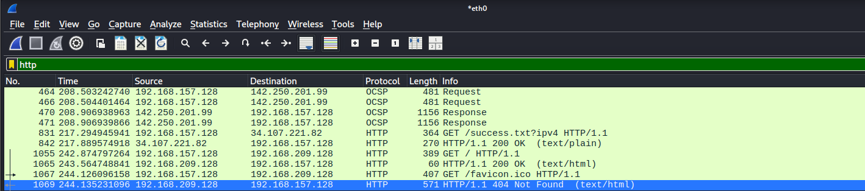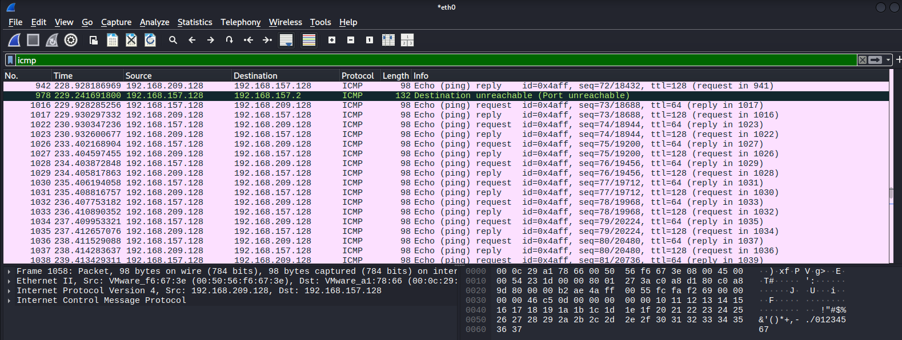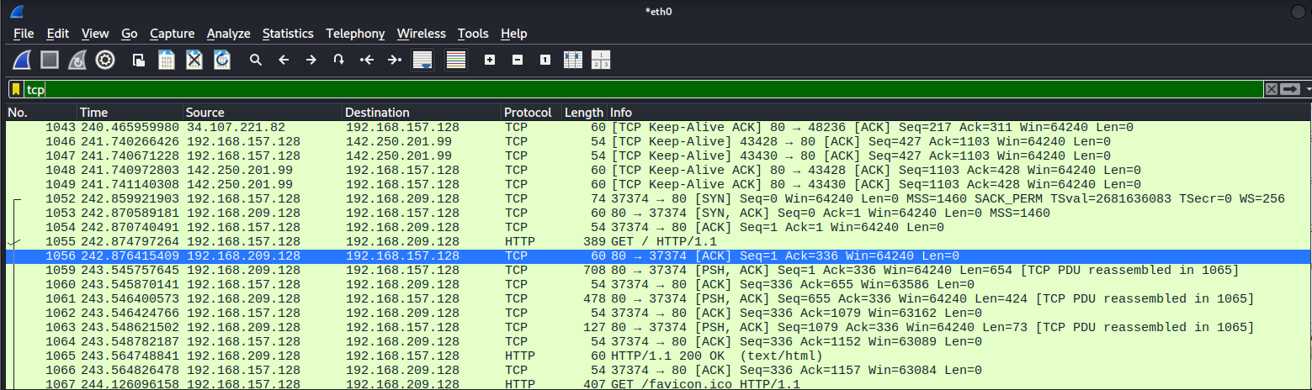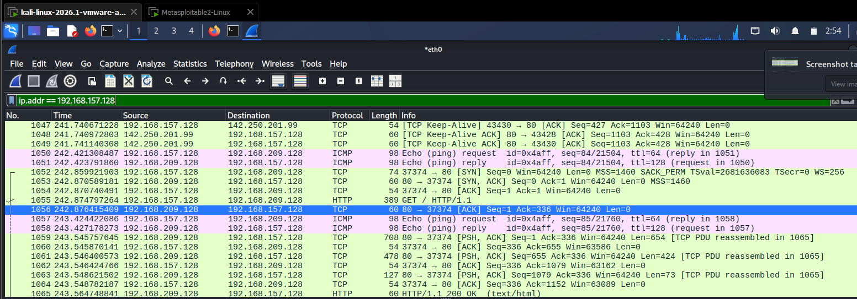

🎯 Goal: Part 1: A Wireshark capture file with annotated findings and a diagnosis report identifying connectivity issues and solutions. Part 2: A wireless security assessment report listing all networks found, encryption types, hidden SSIDs, and password strength evaluation with recommendations.

